Install Power BI Desktop and share the final screenshot of the report view page which appears when power desktop starts.

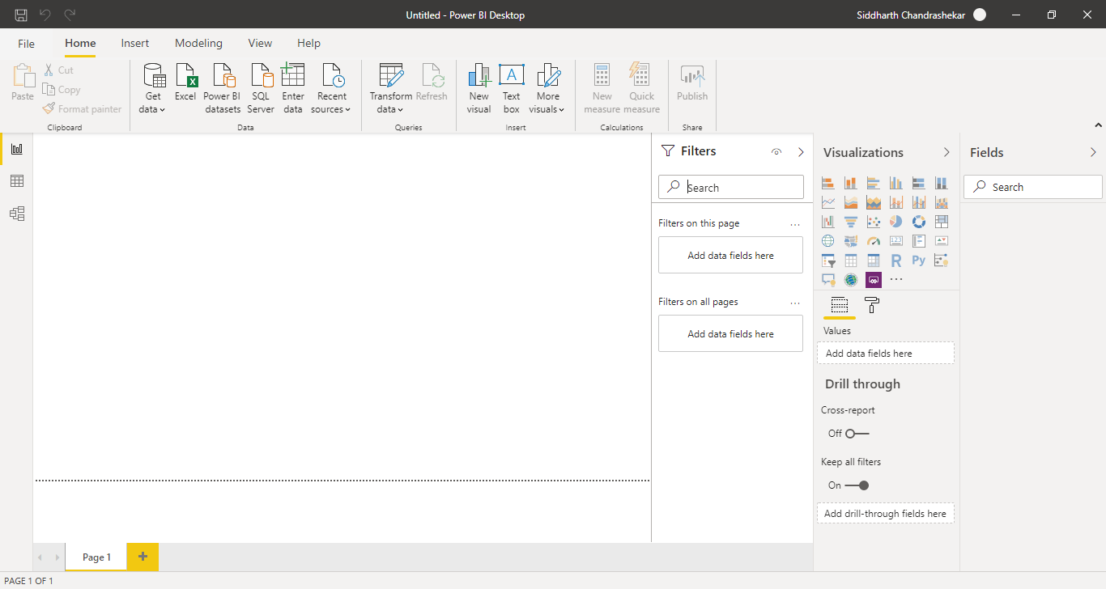

Prepare a document and with the following screenshot

− Report View

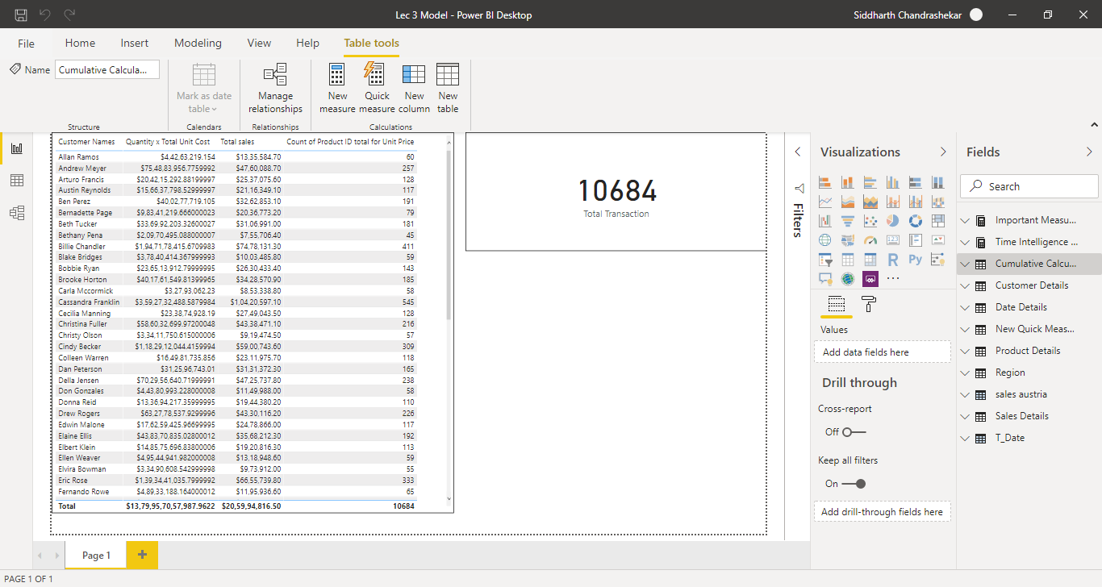

Data View

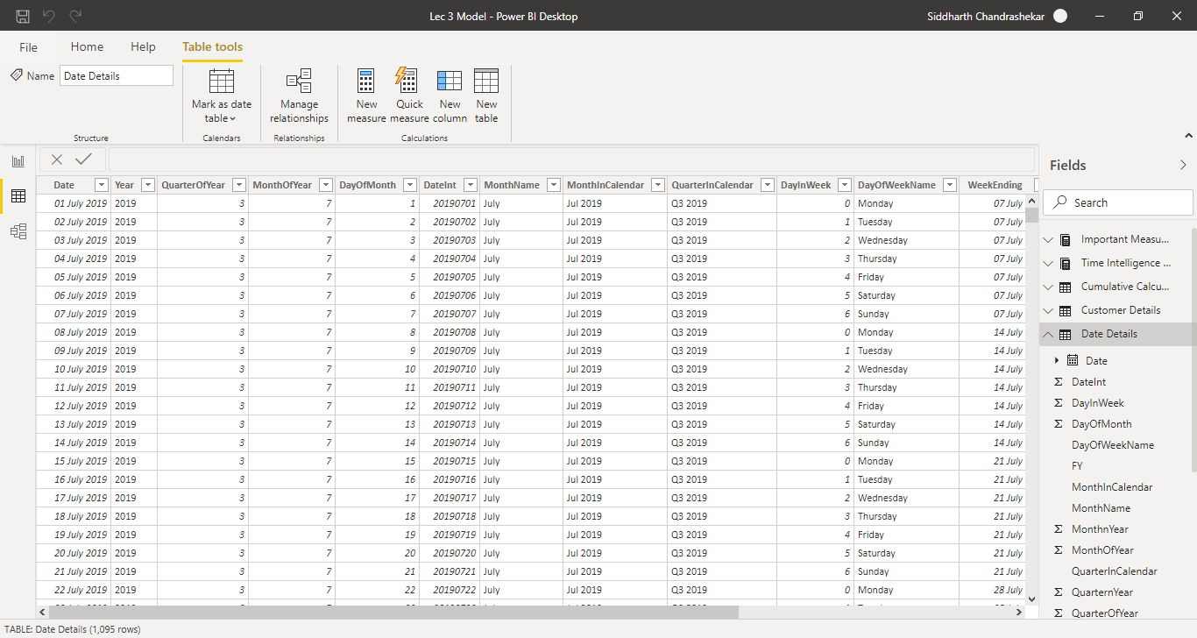

-Model View

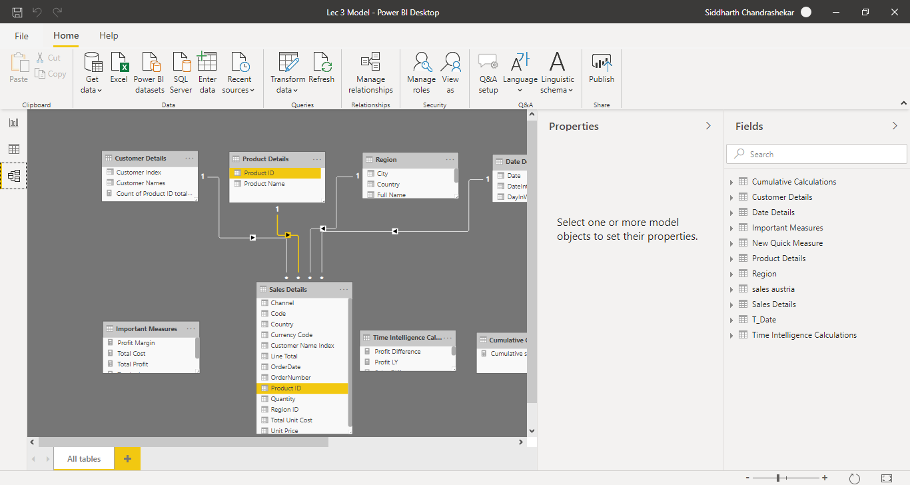

* Power Query Editor

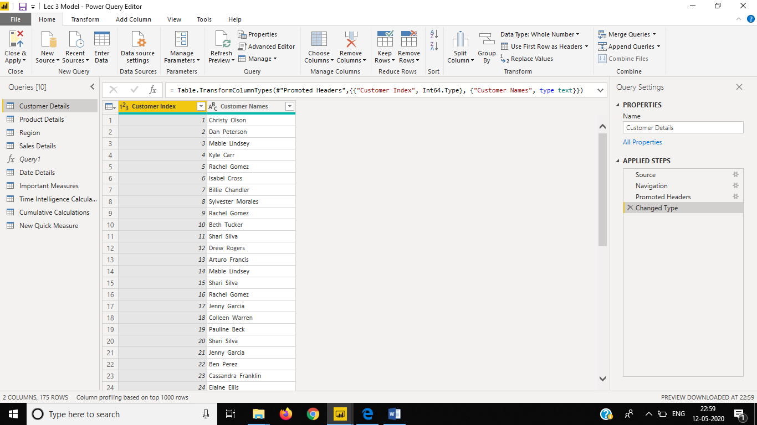

Advanced Editor

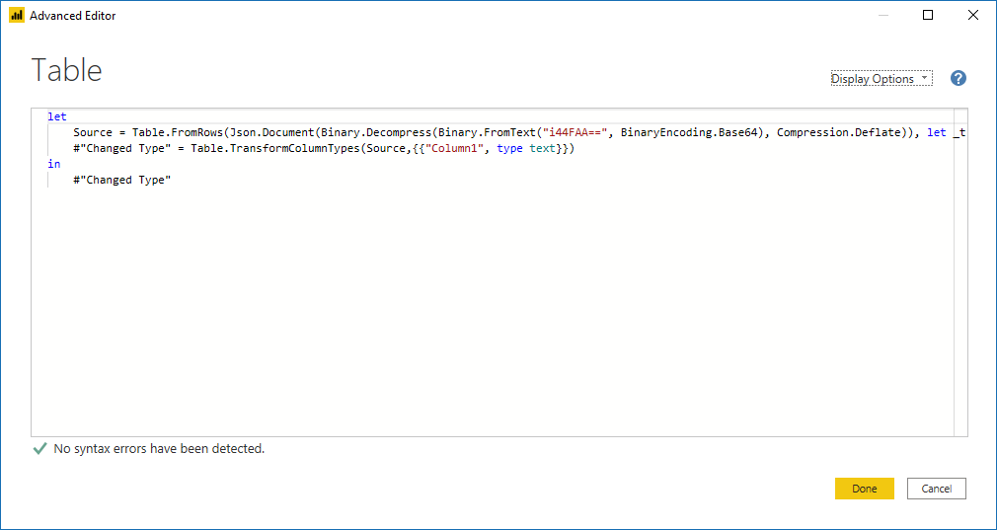

**Power BI Desktop**

# Go from data to insight to action with Power BI Desktop

Create rich, interactive reports with visual analytics at your fingertips—for free.

### Connect to your data, wherever it is

Access data from hundreds of supported on-premises and cloud-based sources, such as Dynamics 365, Salesforce, Azure SQL DB, Excel, and SharePoint. Ensure it’s always up to date with automated, incremental refreshes. Power BI Desktop enables you to develop deep, actionable insights for a broad range of scenarios.

### Prep and model your data with ease

Save time and make data prep easier with data modeling tools. Reclaim hours in your day using the self-service Power Query experience familiar to millions of Excel users. Ingest, transform, integrate, and enrich data in Power BI.

### Provide advanced analytics with the familiarity of Office

Dig deeper into data and find patterns you may have otherwise missed that lead to actionable insights. Use features like quick measures, grouping, forecasting, and clustering. Give advanced users full control over their model using powerful DAX formula language. If you’re familiar with Office, you’ll feel at home in Power BI.

### Deepen your data insights with AI-driven augmented analytics

Explore your data, automatically find patterns, understand what your data means, and predict future outcomes to drive business results. The new AI capabilities—pioneered in Azure and now available in Power BI—require no code, enabling all of your Power BI users to discover hidden, actionable insights and drive more strategic business outcomes.

PRICING – FREE

**Power BI Pro**

Distribute and access insights anywhere by combining Power BI Desktop and Power BI Pro. Collaborate and build reports with colleagues and then publish and share those reports anytime, anywhere, and on any device.

### Discover insights quickly

* Explore data easily by using conversational language and get meaningful answers to data questions asked in your own words.
* Get insights instantly from your favorite applications using pre-built data visualization and report templates.
* Keep your priority analytics handy by pinning your most relevant content, and ensure others see valuable insights by promoting them using administrative tools.

### Get more done with familiar tools

* Get the answers you need quickly using the skills you have today—whether you are most comfortable using other BI tools, Excel, or Azure.
* Increase the impact of your insights by sharing them with teammates in the tools they use every day such as Microsoft Teams, Dynamics 365, and the Microsoft Power Platform.
* Encourage data exploration and insight sharing with an intuitive, familiar experience that looks and works like the other Microsoft technologies your teams already use.

### Govern your data securely

* Help prevent data loss with centrally managed, role-specific data protection and row-level security.
* Meet local regulations on service delivery, data residency, access, and control with [national clouds](https://powerbi.microsoft.com/en-us/clouds/).
* Safeguard your data so that it meets the compliance standards and certifications for your industry.

PRICING – 660 INR (Monthly)

***Power BI Premium***

**Accelerate decision making when everyone has access to insights**

Enable anyone— whether they’re inside or outside your organization—to view all Power BI content including paginated and interactive reports without purchasing individual licenses.

Choose the deployment option that works best for your organization, with on-premises reporting through [Power BI Report Server](https://powerbi.microsoft.com/report-server/), and your choice of geographic region for cloud deployment.

Scale as your needs grow with dedicated cloud infrastructure that gives you control of performance.

**Unlock big data with self-service data prep**

Find the data you need by using prebuilt connectors for common services like Dynamics 365, Azure Synapse Analytics, Salesforce.com, Excel, and SharePoint.

Empower business analysts to ingest, transform, and enrich big data through the already familiar Power Query experience without developing specialized skills or relying on others. [Learn more](https://go.microsoft.com/fwlink/?LinkId=2034388&clcid=0x409)

Prepare data once and then reuse it across multiple Power BI models to drive efficiency and accuracy.

**Simplify data management and access**

Meet data residency requirements by deploying in any region you choose including National clouds.

Decide the best way for users to view and collaborate through flexible reporting types, distribution formats, and embedding options.

Reduce IT headaches with a unified BI tool that includes central governance, security, and management across all users inside or outside your organization.

**Improve publishing efficiency and accuracy of BI content**

Quickly move content from development and testing to production with confidence using the simple visual cues in deployment pipelines.

Rapidly deploy reports with improved consistency and performance without needing special DevOps skills or tools.

Save time and improve accuracy by using repeatable content management processes while personalizing them to fit your organization.

PRICING – 330,190 INR